# Windows Store

Windows Store 1

Finding Apps in the Windows Store 2

App Product Description Pages 8

Your Account and Preferences 13

Your Account 14

Preferences 16

App Updates 17

Your Apps 18

Installing Apps from the Windows Store 20

Uninstalling Apps 22

Updating Apps 23

Submitting Feedback 26

Review an App 26

Report a Violation 30

Try This: Windows Store 32

#### Timing for This Module

|  |  |
| --- | --- |
| Delivery Length: 45 Minutes | Additional Lab Time: 15 Minutes |

#### Overview

As part of the Windows® 8, Microsoft® is introducing the Windows Store. The Windows Store is similar in concept to other app stores that exist on the market today, and it provides one central place to buy and obtain information about apps in Windows 8. The Windows Store will expose two different categories of apps to customers: Windows Store apps and desktop apps.

* Windows Store apps include any of the apps using the new app model described in the previous sections. Windows Store apps are those apps made for the new touch interface in Windows 8. Windows Store apps are only supported on Windows 8 and the only way for end-user customers to obtain this type of app will be through the Windows Store.
* Desktop apps are the traditional Windows apps that have existed for every version of Windows prior to Windows 8, and they continue to be supported from the desktop in Windows 8. This includes apps like Microsoft Outlook® and Adobe Photoshop.

While both types of apps will be exposed through the Windows Store, there is a difference in the way they are handled in the Windows Store:

* The Windows Store provides a place for customers to find, purchase, download, install, and update Windows Store apps. More on these actions will be discussed later.
* Desktop apps in the Windows Store are not managed through the Store itself. Software vendors can publish their apps in the Windows Store, and a page for that app that shows a description of the app and screen shots for the app will be displayed in the Store. However, instead of purchase or download buttons for the app, the user is instead presented with a link that will open the product page for the desktop app on the software vendor's website. However, the app cannot be purchased, installed, or updated through the Windows Store itself.

## Finding Apps in the Windows Store

When you first open the Windows Store, you are presented with the home page of the Store which displays information about featured apps in the Windows Store and different categories where apps are grouped together by a common set of criteria. Tiles for an individual app will show the name and logo for the app, as well as the price and current rating for the app. Category tiles will display only a text title or a short description with a graphic, but no price or rating will be displayed like you see on the individual apps.

In the screen shot that follows, Socialite, Sudoku, and PaintPlay are examples of app tiles. The "Top free" tile is an example a of category tile. You will also notice when viewing the home page of the Windows Store that the groupings of related tiles are split into separate sections, such as the Spotlight and Games section. This is similar to the groupings of tiles on your Start screen.

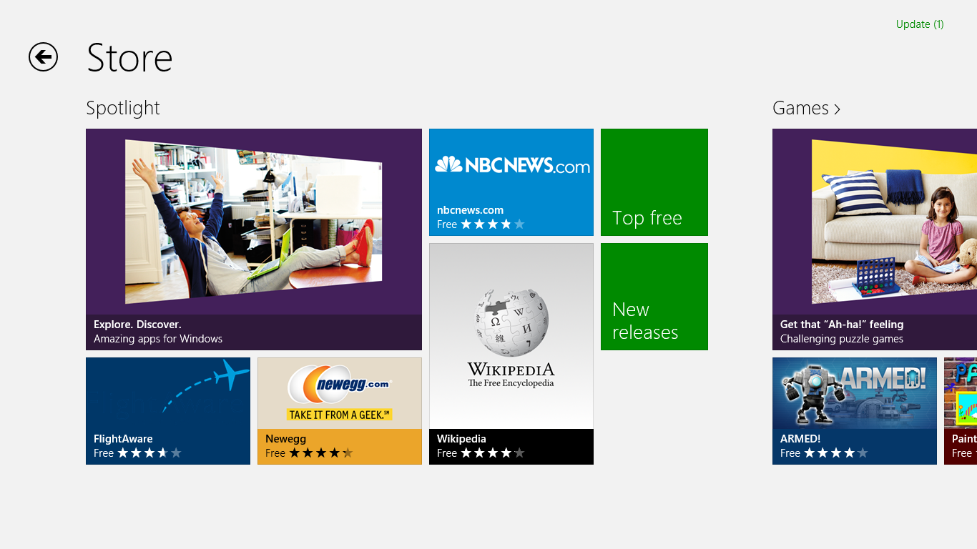

Figure : Windows Store

When you click on one of the category tiles, you are taken to another page where the apps that fall into that category are displayed. The type of page that will be displayed will depend on the type of category.

The large tile under the Spotlight section in the preceding screen shot is an example of a curated category, where the Windows Store team has manually created a group based on their opinions of which apps are appropriate for the given category.

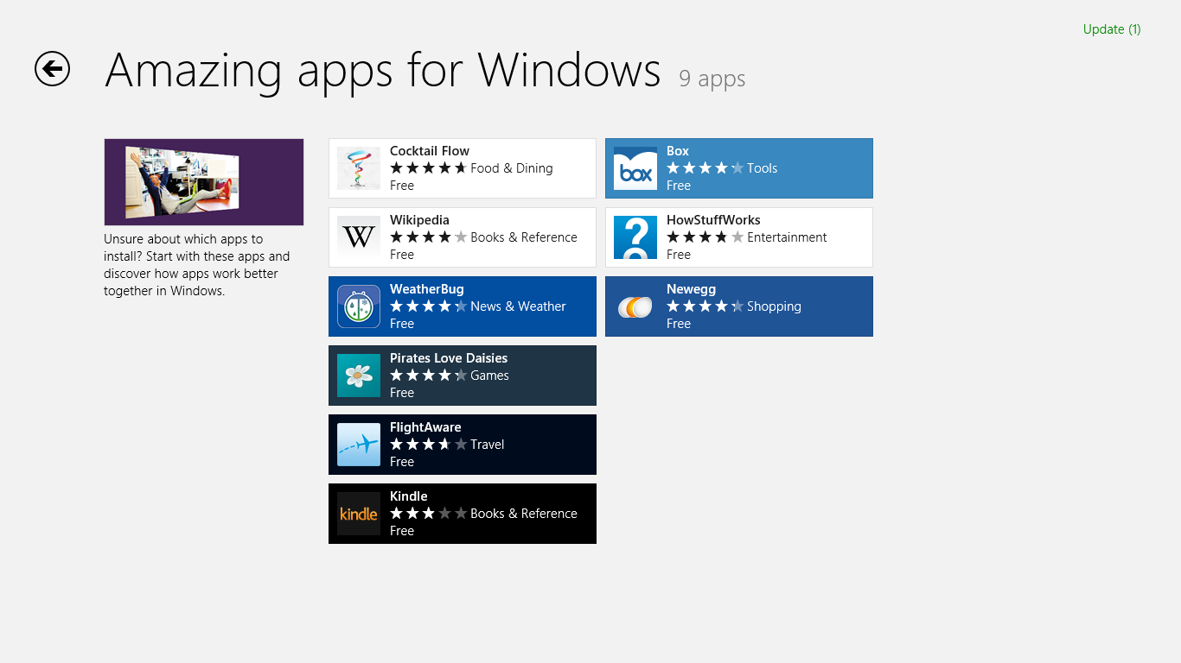

Figure : Curated category

"Top free" is an example of a category that is generated based on specific criteria. In this example, the apps that have the highest star rating in their category are displayed.

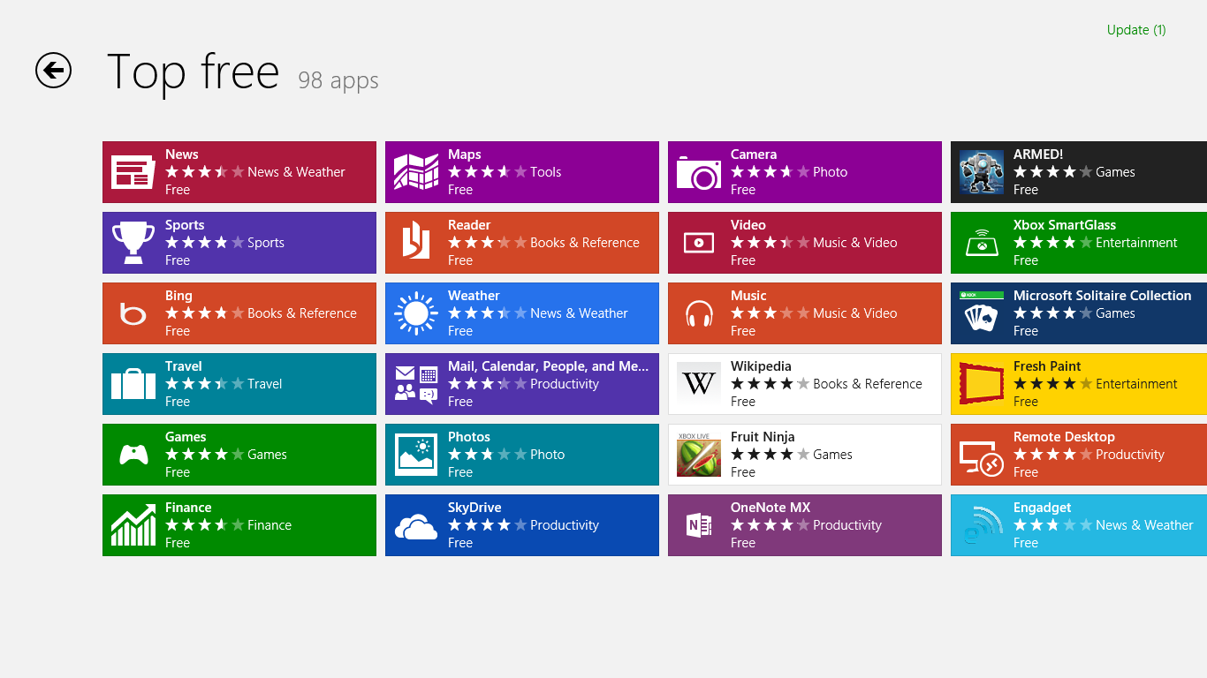

Figure : A “browse” category

Some category tiles are intended to provide a way to browse all of the apps that fall into a specific category or sub-category. These "browse" categories provide a method to filter and sort the view using the menus exposed at the top of the category, as shown in the following screen shot.

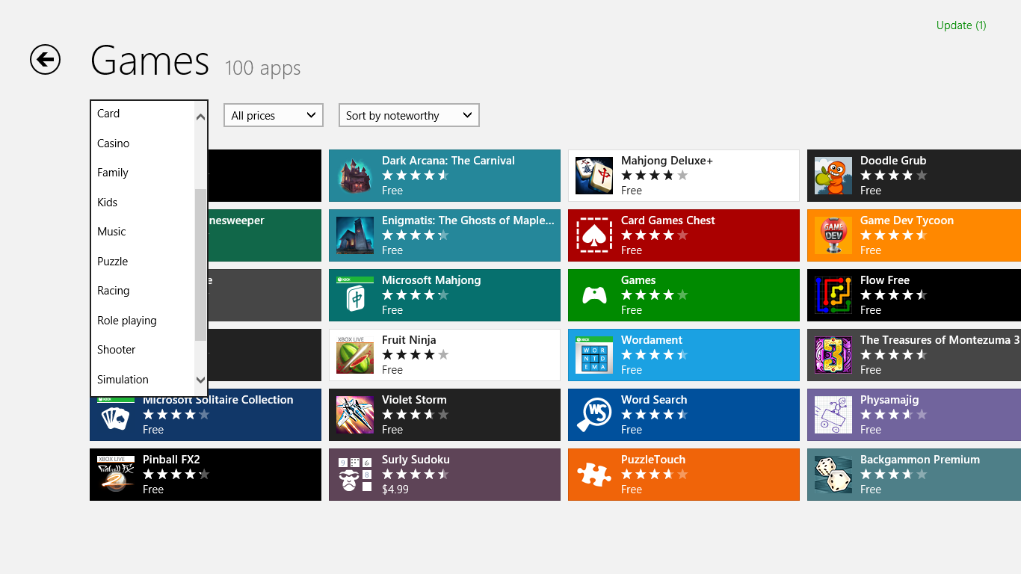

Figure : Browse categories with filters

In addition to finding apps by browsing for them, Windows Store also provides the ability to search for apps. You can begin a search for an app in the Windows Store with the Search charm, which you can also get to by pressing Win+Q. If you do this while inside of the Windows Store, the search scope will automatically be set to search the Store instead of the local PC. You can also initiate a search against the Windows Store by opening the Search charm from anywhere else and then manually selecting Store from the list of apps you can search against.

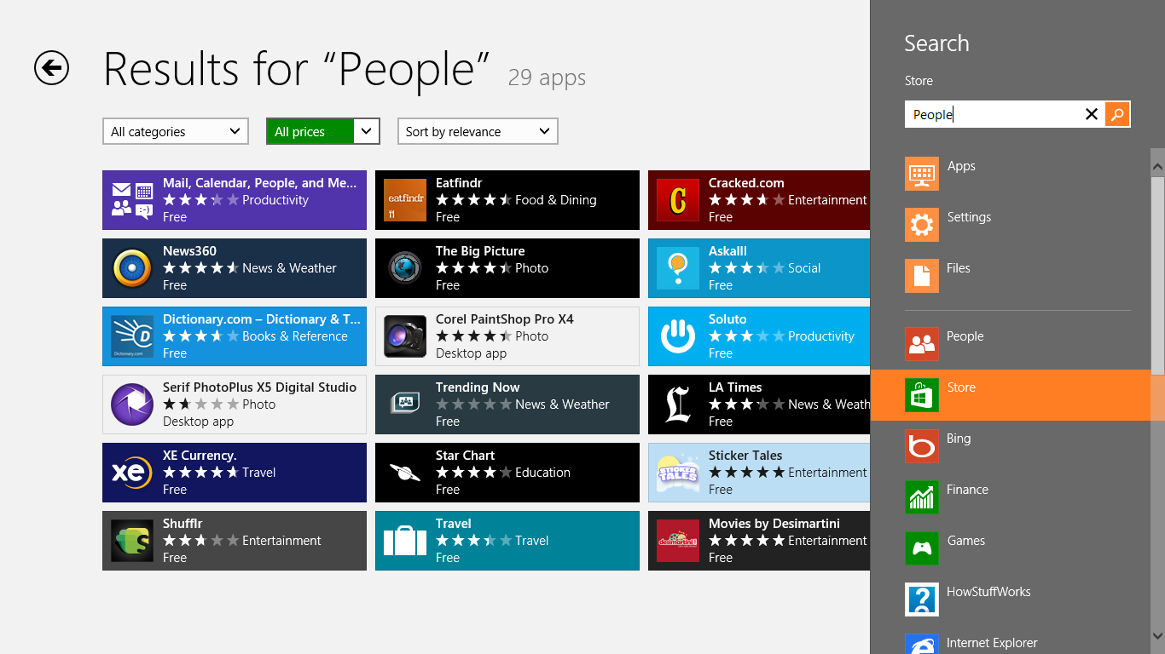

Figure : Searching Windows Store

From the Search charm, you can search for a keyword that might appear in the product page for the app that you are looking for. This could be the title of the app, the developer of the app, or a word that appears in the description of the app. If you have previously searched the Store, you will also see that your recent search terms will be displayed below the search field, such as the term “People” in the preceding screen shot. After initiating the search, you will be taken to a results page that looks similar to the category browsing page illustrated earlier. You will see a list of all the apps that matched your search terms, as well as options to filter and sort the results of that search.

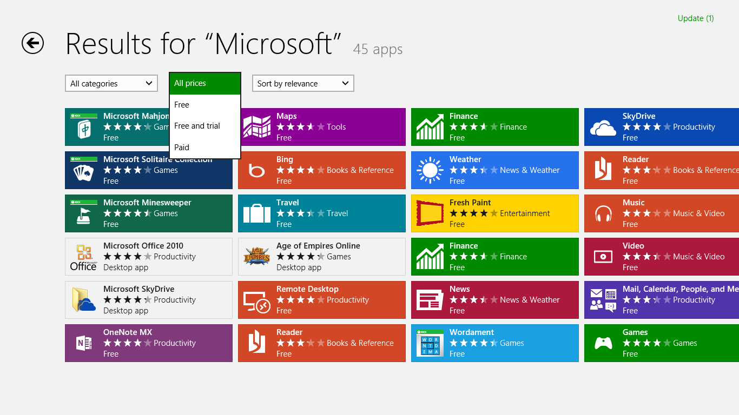

Figure : Search results in the Windows Store

## App Product Description Pages

After you find the app that you are looking for by either browsing or searching for it using the Search charm, selecting the tile for the app will take you to the product description page (PDP) for that app. From this page, you can find more information about the app, purchase the app, and download and install the app. The following screen shot shows an example product page.

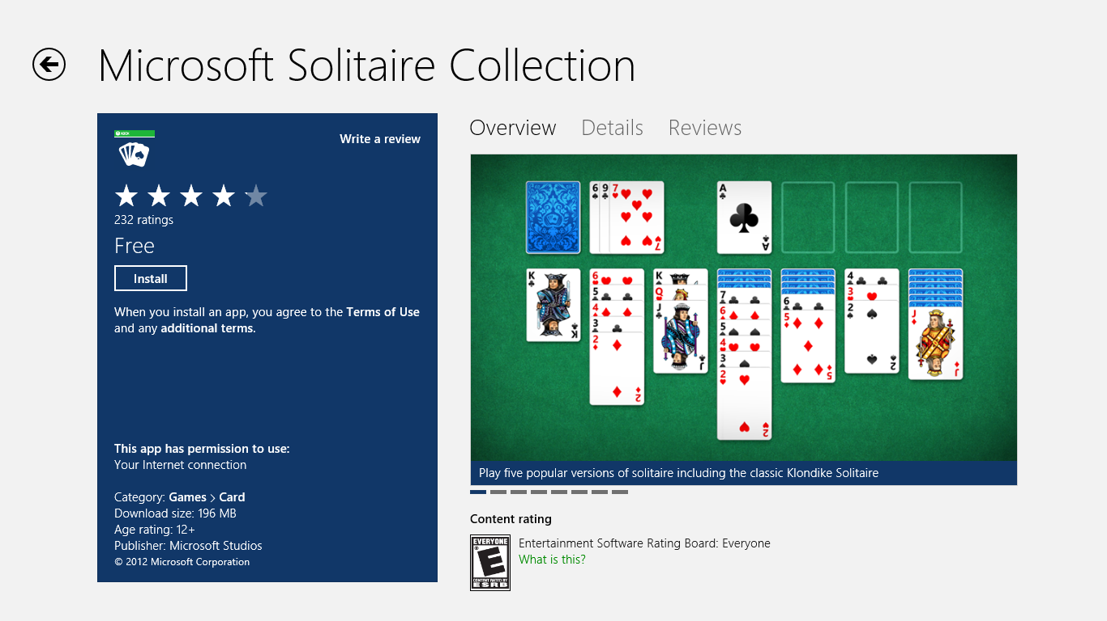

Figure : Product Description Page

As seen in the screen shot above, the product page is divided into two main sections. On the left, we see the following:

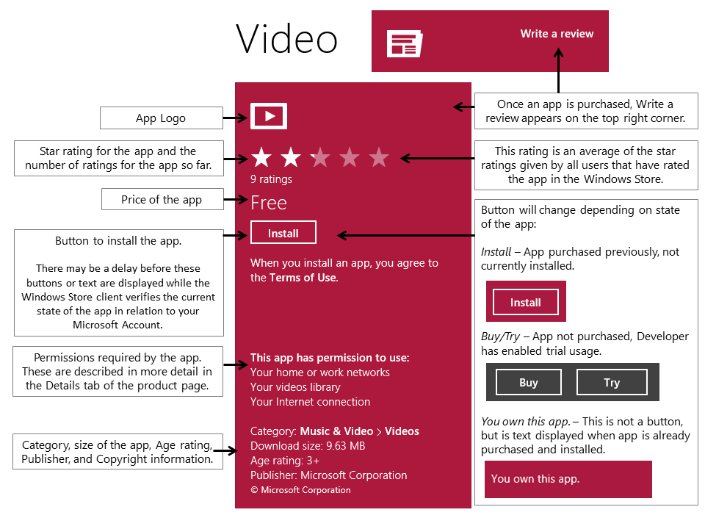

Figure : Product description page

On the right side, there is a tabbed view, showing **Overview**, **Details** and **Reviews**.

Table : PDP Tabs

|  |  |
| --- | --- |
| **Overview tab** | Figure : Overview Tab  On the **Overview** tab, you can see screenshots and a description of the app, as well as the following:   * Links to the website and support page for the app * Link to the developer’s privacy policy * Link to report a problem with the app. The Report app link will be covered in more detail in the Submitting Feedback section.   You can switch between screenshots by clicking on the left or right side of the image, or by swiping. |
| **Details tab** | Figure : Details Tab  On the **Details** tab, you can see Release Notes, supported processors and languages, and the permissions that the app requires to function.   * The release notes provide a description of what has changed in the last update. * Supported processors will be some combination of x86, x64, and ARM. * More details about permissions are described in the Permissions section below. |
| **Reviews tab** | Figure : Reviews Tab  On the **Reviews** tab, you can submit a review which describes their opinion of the app.   * If another user wants to provide feedback about the helpfulness of the review, they can do so with the **Was this review helpful?** option that is part of every user review. Other users can then look at the review rating to make a determination about the validity of a given user review. * If you submit a review with an issue, such as the review contains offensive or illegal material, then another user can report the problem using the **Report this review** link. |

## Your Account and Preferences

There are several settings related to the Windows Store that are accessible through the Settings charm. The primary locations for these settings are on the Your account, Preferences, and App updates pages, as shown in the following screen shot.

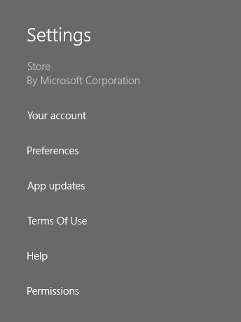

Figure : Windows Store Settings

### Your Account

From the Your account page, you will see options related to the account you used to sign in to the Windows Store, your payment method, and the PCs that you have installed apps on with this account.

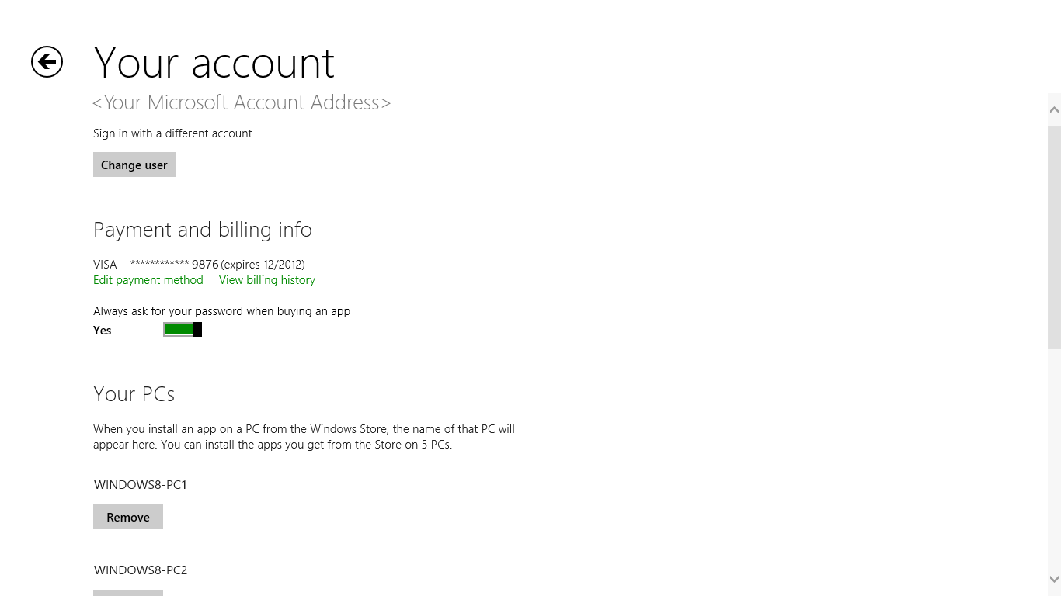

Figure : Your account page

All of your account activity and purchases are tied to your Microsoft account. If you are signed on to Windows using a connected account, that Microsoft account will automatically be used in the Windows Store:

* With a connected account, you can use the **Sign out** button, but signing on will not prompt for credentials. Your connected account will be used automatically.
* With a connected account, clicking the **Change user** link has no effect. A progress indicator will appear, but afterward, your connected account will be used automatically.
* With a local account, you can still open and browse the Store, but the first time that you attempt an action that requires a Microsoft account, you will be prompted for your account information.

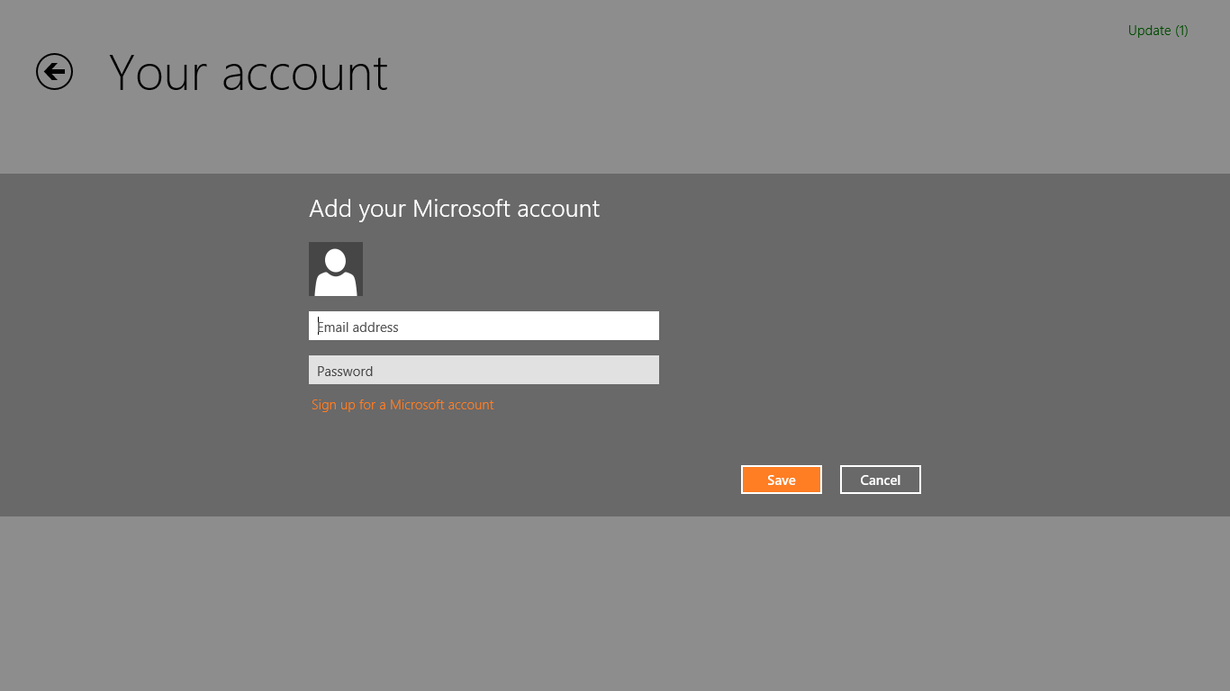

Figure : Sign in with a Microsoft account

* With a local account, clicking the **Change user** link will prompt you with the same **Sign in** dialog box that you see in the preceding screen shot.

By default, purchasing an app asks you to enter the password for your Microsoft Account. You can change this behavior by setting the **Always ask for your password when buying an app** option to **No**, making it so that any attempt to purchase an app happens automatically. Use caution with this setting because it enables anyone with physical access to your PC to purchase apps.

The **Your PCs** section shows a list of the PCs that you have purchased and installed apps from with the Microsoft account that you are currently signed in with. Licensing in the Windows Store allows you to install your app on up to five PCs simultaneously. Those five PCs are listed under **Your PCs**. If you need to remove an older PC to make room for a new PC, you can use the **Remove** button. You can only remove one PC every 30 days using this method.

### Preferences

On the Preferences page, you will see options that affect how the Store filters your search results when attempting to find an app.

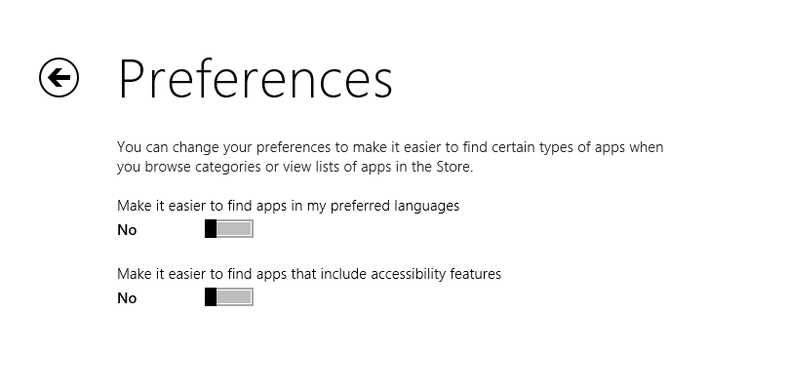

Figure : Preferences page

### App Updates

From the App updates page, you can control whether updates are installed automatically and you can manually initiate a check for updates. You can also sync your app licenses from here.

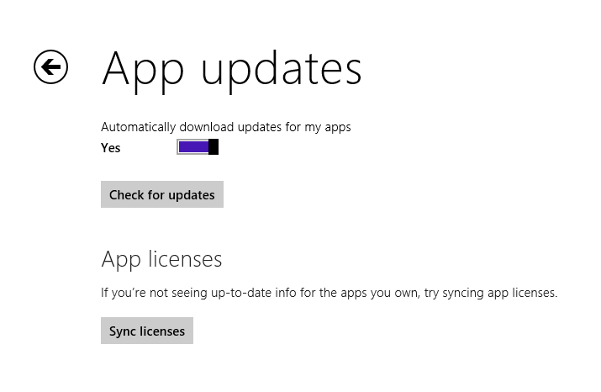

Figure : App updates

* Click **Check for updates** to manually check for updates for any of your currently installed apps.
* By default, the Store client will download and install updates for apps automatically. You can configure this option using the **Yes/No** slider under **Your apps**.
* Use the **Sync licenses** button if you are not seeing up-to-date licensing information related to an app. This will primarily be needed for scenarios where you are not signed in with a Connected Account ,meaning that your settings are not syncing between PCs, and on another PC you did something to change the licensing state of the app. Examples of actions that would change the licensing state of an app would be converting from the trial to a full version of the app, or performing an in-app purchase. Use this button when you are not seeing those purchases reflected on the PC you are using.
  + If you are using a Connected Account this information should sync automatically.

## Your Apps

The Windows Store provides a quick way to see all of the apps that you have purchased with the Microsoft account that you are currently signed in with. You can quickly get to this view by swiping up from the bottom or right-clicking, and then selecting **Your apps**.



Figure : Your apps in top bar

This will take you to a page where you can see all of your apps, as well as when you purchased them and whether or not they are installed on the current PC.

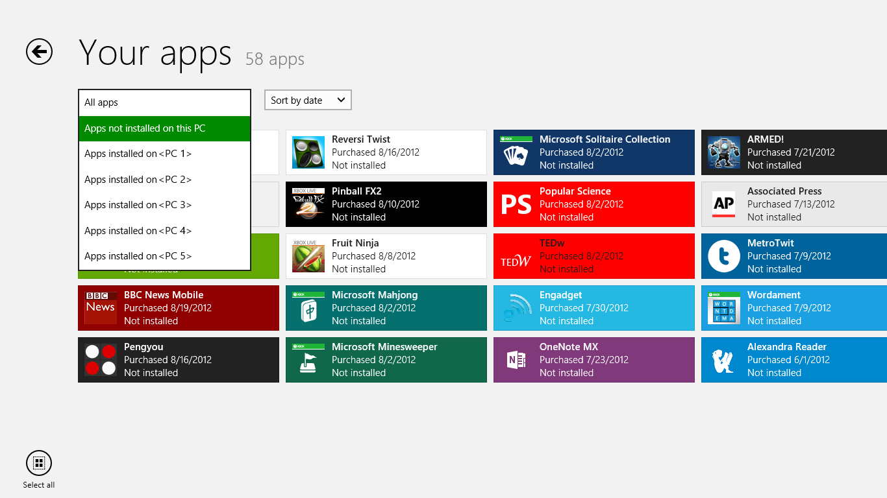

Figure : Your apps page

* You can use the **Select all** command followed by the **Install** command to quickly install all the apps you own that are not currently installed on the PC you are now using.

**Note:** The **Select all** command will not actually select all the tiles in this view. Only those tiles that are not already installed will be selected in order to facilitate quickly installing all the apps that you don’t already have installed.  
  
This interface is the place to point customers when they ask where they can see all of the apps they have purchased with their account or if they want to install all the apps they previously purchased on another PC.

## Installing Apps from the Windows Store

The Windows Store client handles all of the work related to downloading, installing, and updating a Windows Store app. All Windows Store apps use the same installation method, and the experience is the same for all of them, which creates a much more consistent experience for customers than what they experience installing desktop apps.

The table below shows the process that you will go through in order to download and install an app.

Table : Install apps from the Store

|  |  |
| --- | --- |
| **1** | Click the **Install**, **Buy**, or **Try** button on the app product page.    Figure : Click the Install button |
| **2** | The Windows Store client immediately navigates to the previous category page that you were on, and text is displayed on the top-right corner indicating that the installation for the app is in progress.    Figure : Installation status text on top right corner |
| **3** | Clicking on the text on the previous step will you to a page where they can see the current status of the installation. Here we see that the app is currently being downloaded. After the download is complete, the status will change to installing. Once it has finished installing, the app will be removed from the installation status page.    Figure : App installation status |
| **4** | After the installation is completed, Windows displays a notification stating that the app was installed.    Figure : Installation complete notification |
| **5** | Once the app is installed, you can see the tile for the new app on the far right end of the Start screen. The tile will be created as the last tile of the last group initially, though you can move it elsewhere on the Start screen.    Figure : App tile on Start after installation completes |

## Uninstalling Apps

The process for uninstalling Windows Store apps is different as well. Unlike with desktop apps, Windows Store apps are not listed in the **Programs** section of the desktop Control Panel. The process for removing Windows Store apps has been vastly simplified compared to desktop apps.

In order to uninstall a Windows Store app, you need to right-click the tile with your mouse or swipe down on the tile with your finger. This will show app commands for **Unpin from Start** and **Uninstall**:

* If your goal is to simply remove the tile from the Start screen, but not necessarily to remove it from the PC altogether, you can accomplish this by selecting the **Unpin from Start** command.
* If your goal is to completely remove the app and its settings from the PC, you can do that by selecting the **Uninstall** command.

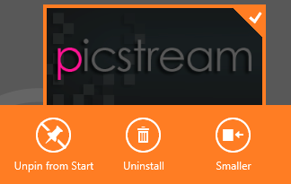

Figure 24: Use Uninstall button to remove app

A confirmation dialog box appears that indicates that the app and its settings and associated data will be removed from the PC.

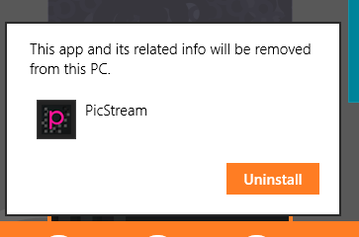

Figure : Uninstall confirmation

After selecting **Uninstall** in the confirmation dialog box, the process completes and the app, its data, and its tile are all removed. In most cases, the installation will be nearly instantaneous.

## Updating Apps

The Windows Store client will also ensure that your Windows Store apps are updated with minimal user interaction. By default, updates for apps are downloaded and installed every day. You can also manually initiate an app update from the Windows Store client.

When updates for an app are available, the Store tile will display a budge with a number on the lower-right corner. The number represents the number of updates available.

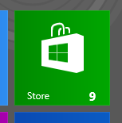

Figure : Update badge on Store tile

While in the Store client, the upper-right corner of the screen will indicate that updates are available.

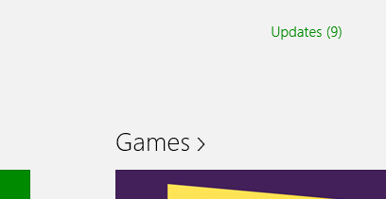

Figure 27: Update status text in Store

Selecting the **Updates** link takes you to a page where you can install updates either individually or all at once.

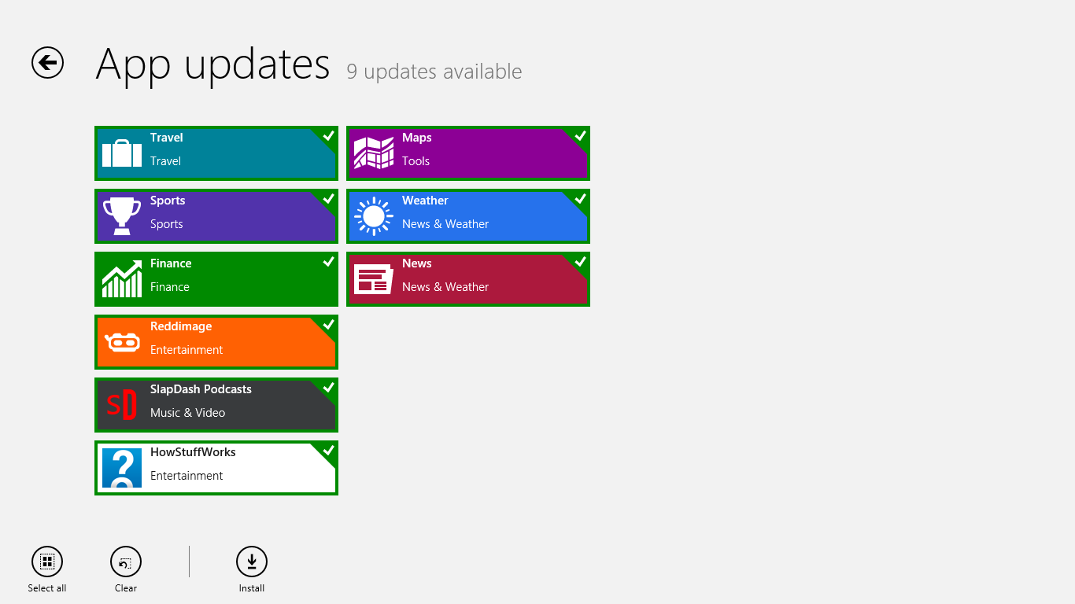

Figure : App updates page

After you select **Install**, you will see text on the upper-right corner indicating that the installation is in progress.



Figure : Update installation status text

Selecting this text will take you to a page where you can see the installation status for the apps that you are updating. As the installation progresses, that status changes from downloading to installing, and then finally the app will disappear from this status screen.

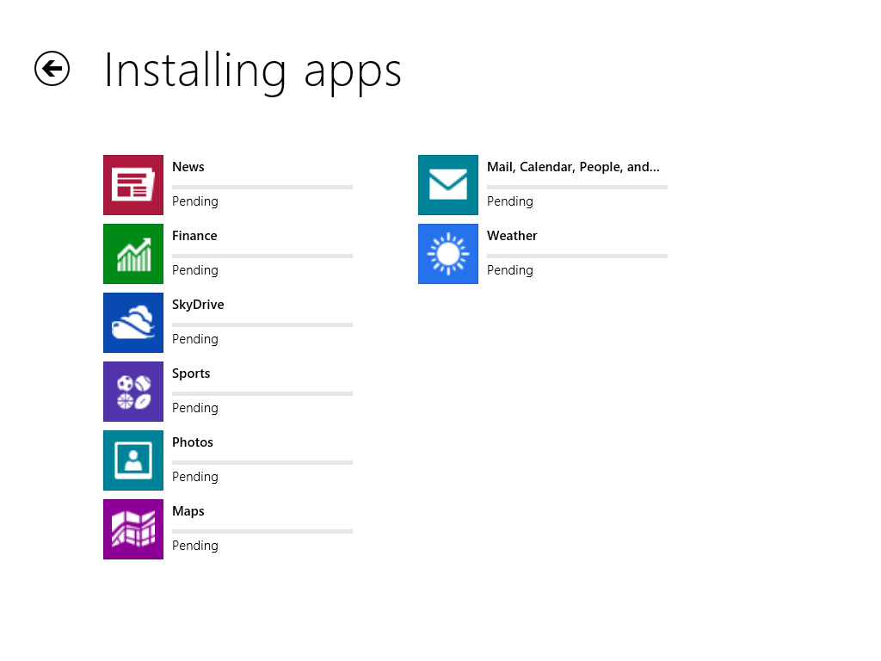

Figure : App installation status page

## Submitting Feedback

The Windows Store provides several different options for providing feedback. The primary mechanism for submitting feedback is to submit a review of an app in the Store, but you can also report a app for violating the terms of service for the Windows Store. We will discuss both of those in the sections below:

### Review an App

After installing and using an app from the Windows Store, you have the ability to submit a review of the app where they provide their opinion of the app or a description of their experience with the app. You have two options for doing this:

* Submit a star rating for the app.
* Submit a written review of the app.

#### Submit a Star Rating for the App

You can submit a star rating for an app that you have already installed from the app's product page in the Windows Store. In the description on the left, you will see the apps current star rating on a scale of one to five stars, as well as the number of ratings received to date. The star rating that is displayed is an average of all of the star ratings that have been submitted for the app. In the screen shot below, we can see that there have been six ratings, and the average star rating for the app is almost 4 stars out of a possible 5.



Figure : Average rating

You can submit your own star rating for the app by clicking on one of the stars in the same description area. Select a star to give a rating at the selected level. After submitting the star rating, the view switches from showing the average star rating to only the star rating that you submitted, as shown in the screen shot below.



Figure : Your rating

From this point on, the product page will always show your app rating instead of the average rating. You can always change the star rating by going back to the product page for the app and selecting another star.

If you want to see the average star rating for a given app after you’ve rating it, look at the tile for the app in the Windows Store in either a search results page or a category page. The following is an example of this.



Figure 33: Average rating on app tile in Store

#### Submit a Written Review of the App

In addition to providing a star rating for the app, you can also submit a written review that details your experience with the app. You can do this by clicking the **Write a review** link in the app description pane on the left. The **Write a review** link is only visible if you have installed the app on your PC.



Figure 34: Click the Write a review link

Clicking this link will take you to the Write a review page, an example of which is shown in the following screen shot.

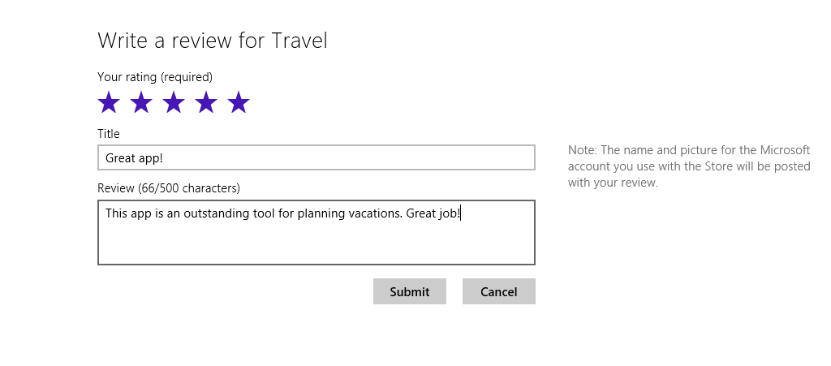

Figure : Write a review for an app

Submit a review on this page by doing the following:

1. Select a star rating if you have not done so already.
2. Provide a title for your review.
3. Write a review describing your experience with the app.
4. Click the **Submit** button when you are finished.

We recommend that customers submit reviews that are as specific as possible, and provide constructive and actionable feedback in their review. This will enable app developers to use that specific feedback to add or improve features in the app.

After submitting the review, you will be taken back to the product page for the app with the **Reviews** tab selected. There will be a delay before their review is posted, as indicated in the following screen shot.

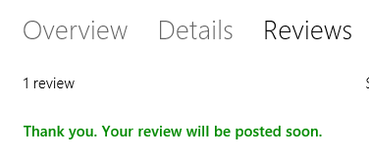

Figure 36: Your review has been submitted

After a period of time, the review will appear on the **Reviews** tab.

#### Was This Review Helpful?

In addition to providing feedback about the app itself, you can also submit feedback about a given review of the app by using the **Was this review helpful** option that exists under each review. The following screen shot shows an example.

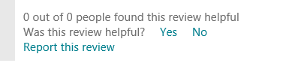

Figure : Was this review helpful? link

After clicking **Yes** or **No**, the number of people who found the review helpful will be updated. This text may not update immediately.

This rating can give others guidance on how seriously to take a particular review, and how many other people agree or disagree with the review. One likely scenario would be when a particular user decides they want to post an extremely negative review just for their own entertainment. (This is called "trolling" on the Internet). If several other people vote that the review was not helpful, that will warn new users that this particular review should not be taken seriously.

### Report a Violation

So far, this module has discussed different methods of submitting feedback for the purpose of letting other potential users of the app know about your experience with the app. The next category of feedback deals with a situation where there is an actual issue with an app or review. Examples of possible issues with an app might include any of the following:

* Offensive content
* Child exploitation
* Malware or virus
* Copyright, trademark, or other intellectual property infringement
* Other

This type of feedback is sent to the Windows Store support team, where they triage the feedback and take appropriate action. Processes and details related to the Windows Store support team are out of scope for this particular Windows Store training module.

#### Report a Problem with an App

You can report a problem with an app to Microsoft by using the **Report this app for violating the Store’s Terms of Use** link at the bottom of the **Overview** tab.

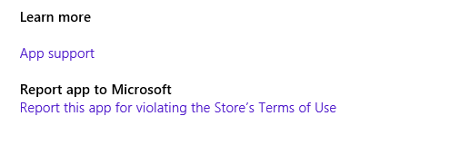

Figure : Report app to Microsoft link

This link will take you to a page where you can describe the problem that you are reporting. You will also need to select the particular category that the feedback falls into.

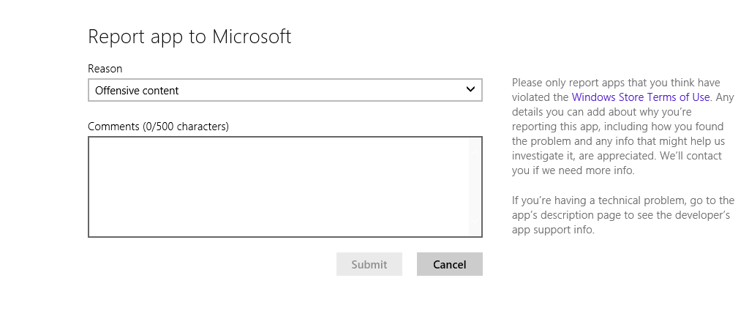

Figure : Report app to Microsoft page

Note that this type of feedback is primarily intended for situations in any of the categories described earlier, as opposed to crashing or stability problems with the app itself. A user can report technical problems like that by either contacting the app developer support directly, or by submitting a review of the app describing the problem.

#### Report a Problem with a Review

In some cases, a there may be a problem with a review that was submitted by another user. However, the process for reporting a problem with a review is much shorter. If you find a problem like an offensive review, you can click the **Report this review** link at the bottom of the review, like the one shown in the following screen shot.

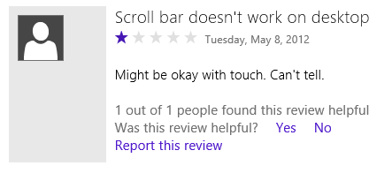

Figure : Report this review link

Clicking the link reveals a menu where you are asked to define what the problem with the review is.

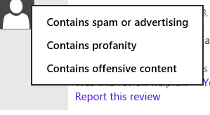

Figure : Define what kind of problem you see with the review

After selecting one of the menu options, the Windows Store team is notified that they need to verify whether or not the review is actually a problem. This process is described in more detail in the training for the Windows Store team.

## Try This: Windows Store

* Find and install three apps from the Windows Store.
* Uninstall and reinstall one of those apps.
* Submit a review for one of these apps.